Automotive Parameter Monitoring Using CAN
AIM:
This project presents an Automotive Parameter Monitoring System using CAN (Controller Area Network) protocol. The system monitors key vehicle parameters such as fuel level, engine temperature, and indicator status in real time. Sensor data is transmitted through the CAN bus to a central controller and displayed on a digital dashboard.
INSIGHT:
- Knowledge of Embedded-C programming
- Thorough with the LPC2129 Architecture, General purpose I/O Interface, ADC & CAN interface
- Understanding of CAN protocol
BLOCK DIAGRAM:
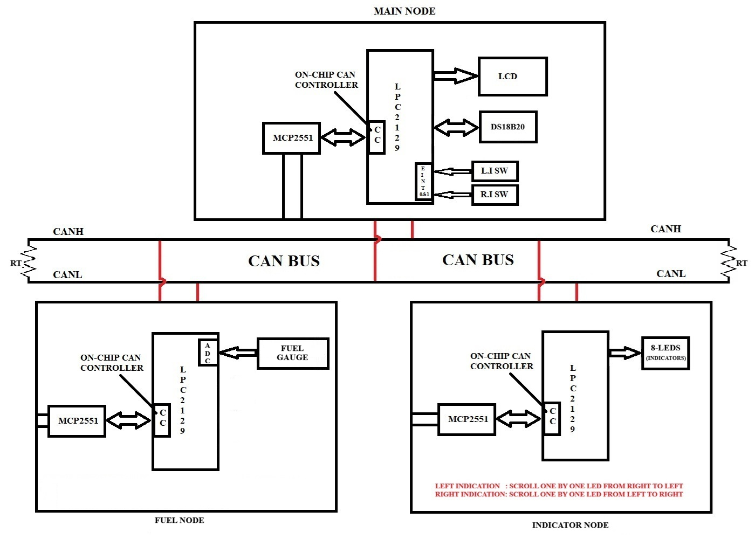

HARDWRAE REQUIREMENTS:

- LPC 2129
- CAN Transceiver (MCP2551)
- LEDS
- LCD
- Switches
- DS18B20 Temperature Sensor
- Fuel Guage
- USB to UART Converter

SOFTWARE REQUIREMENTS:

- EMBEDDED C – PROGRAMMING
- KEIL-C COMPILER
- FLASH MAGIC

SEQUENCE TO BE FOLLOWED FOR IMPLEMENTATION:
- Create New Folder in your server/laptop/PC and save that folder with your project name
- Individually can check each and every module.
- First check lcd to display character constant, string constant and integer constant.
- Next check the on-chip ADC by connecting variable voltage (from potentiometer) and display input value on LCD.
- Then develop logic for reading the Fuel gauge sensor information by using on-chip ADC and display it (Fuel %) on LCD.
- Then develop logic for reading the temperature sensor (Engine temperature) information and display it (engine temperature) on LCD. (refer LMS for DS18B20 temperature working code)
- Then check the external interrupt (EINT0 & EINT1) working condition with the help of basic program.
- Then refer the LMS for on-chip RTC working code and test it on hardware board.
- Then download the CAN basic code from LMS and test it on hardware boards.
- Once all the above modules are checked then start preparing the main code for each node.
- MAIN NODE: In the main node, the system continuously reads the temperature data and displays it on the LCD in real time. Whenever an interrupt is generated (such as a switch press for indicator control), the controller immediately sends the corresponding indicator signal to the indicator node through the communication bus and updates the indicator status on the LCD.
Additionally, the main node receives fuel level information from the fuel node and displays the updated fuel status on the LCD. Thus, the main node performs three primary tasks: continuous temperature monitoring, interrupt-based indicator control, and fuel data reception with real-time display.
- INDICATOR NODE: Continuously waiting for the data from the main NODE using CAN. If any data is received from main NODE, based on that it is controlling the indicator signals connected to microcontroller. Refer the block diagram for how to give the indicator signals with the help of LED’S.
- FUEL NODE: The fuel node continuously reads the fuel gauge sensor signal using the on-chip ADC of the microcontroller. The analog output from the fuel sensor is converted into a digital value and processed to calculate the fuel level in percentage, ranging from 0% (empty tank) to 100% (full tank).
This calculated fuel percentage is then periodically transmitted to the main node, where it is displayed on the LCD for real-time monitoring of the vehicle’s fuel status.
- If you’re getting this output, then your project is completed.

************************** ALL THE BEST ***************************

